StockTake Adjustment - Workflow Functional Document

Application: | NGERP-CENTRA
WorkFlow: | Store to Shelf
WorkFlow Item Name: | Stocktake Adjustment

Description
This workflow used to create the Stocktake Adjustment in to the ROW. Which may help to move to stock from one region to others.

Work Flow Process:

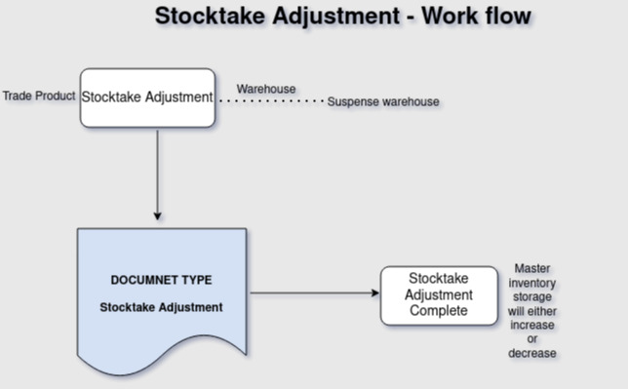

Business Rules:

- In our Stocktake adjustment, we categorize products into Trade.
- Physical inventory is used to master inventory storage will decrease for that we are using stocktake adjustment document types in Stocktake adjustment.
- Document type : StockTake adjustment
- Stocktake adjustment : When selecting the StockTake adjustment Document type, we decrease the product quantity within the Suspense warehouse and for the same product.

Stocktake Adjustment Authorization:
- After create Stocktake adjustment move the StockTake adjustment Authorization screen. Based on StockTake adjustment Screen document type the product storage will decrease after complete StockTake adjustment Authorization screen.

